Fundamental Critical Care Support Course
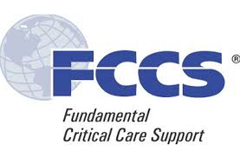

Miami Valley Hospital
Thursday, August 20 & Friday, August 21, 2026

Open to ALL physicians, advanced practice providers, nurses, and respiratory therapists who work in critical care areas
Topics Covered:

Basic ventilator management  Trauma resuscitation  Acute coronary syndromes  Critical care in pregnancy  Skill stations | Management of shock  Neurologic support  Fluids and electrolytes  Infectious disease  …and more!

Participants may claim up to 15.75 hours of CME/CEU credits during this 2-day course

Course Fee: $160

Course Director: Gregory Semon, D.O.

Follow this link to register:
https://secure.qgiv.com/for/wspi/event/fccscc/
Questions? Email Rebecca Thorpe, rlthorpe@premierhealth.com

Hurry…. space is limited!

Registration deadline: June 24, 2026

